Contents

1. Inteken 2

2. Kledingstuk 2

3. Kliënt 3

4. Kombers 4

5. Kontant 4

6. Gebruikers 5

7. Data 6

# Inteken

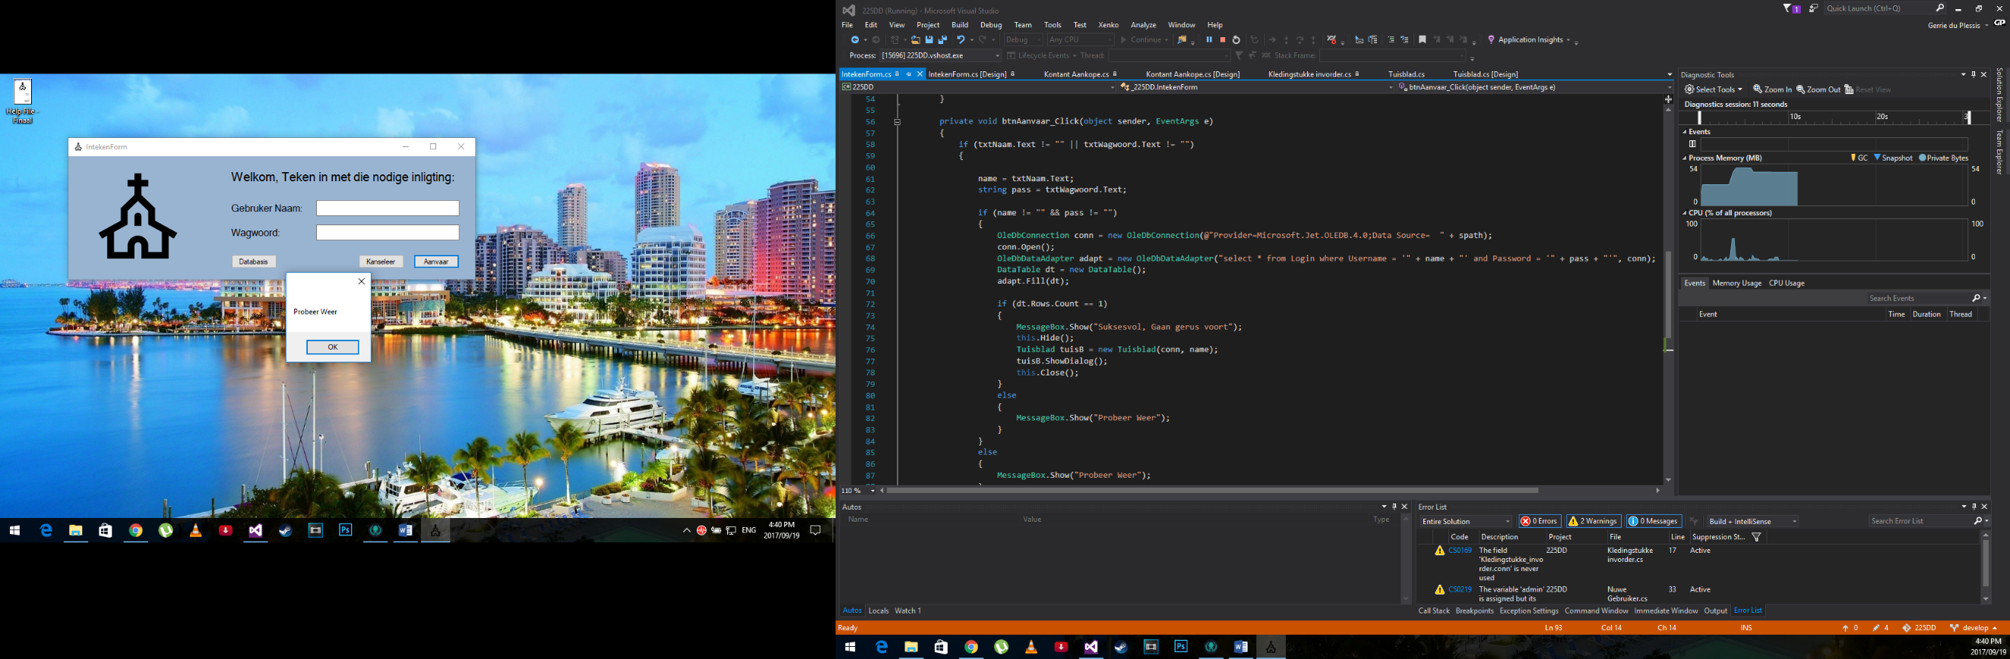

Validation test to see whether the user even put in a value for “Gebruiker Naam:” and “Wagwoord:”.

The “Probeer Weer” message box will pop up when a problem were found.

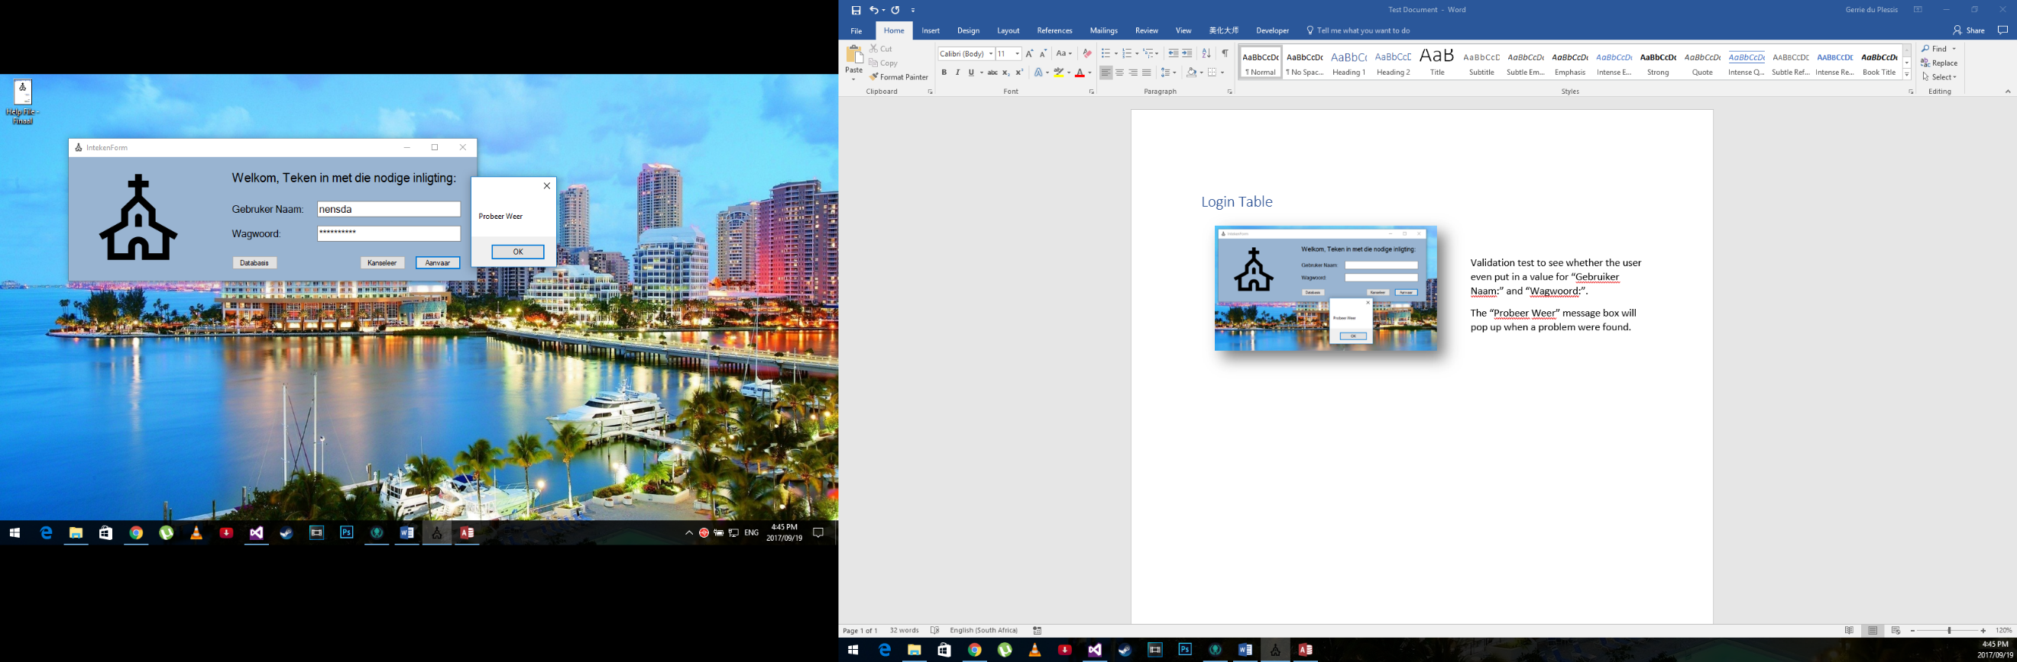When random data, that are not in the database, are entered. The message box “Probeer weer” will pop up to tell you that your username or password were entered incorrectly.

# Kledingstuk

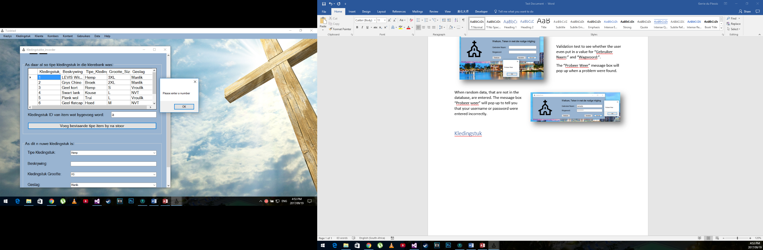

When the user wants to select a product that were in the system before, they can select it by giving the “Kledingstuk ID”. Therefore, the only data the textbox will approve is a number. This means when a letter is entered like in the picture, the program will give an error.

The user then gets the opportunity to give the correct input.

This will go on until the program gets an integer input.

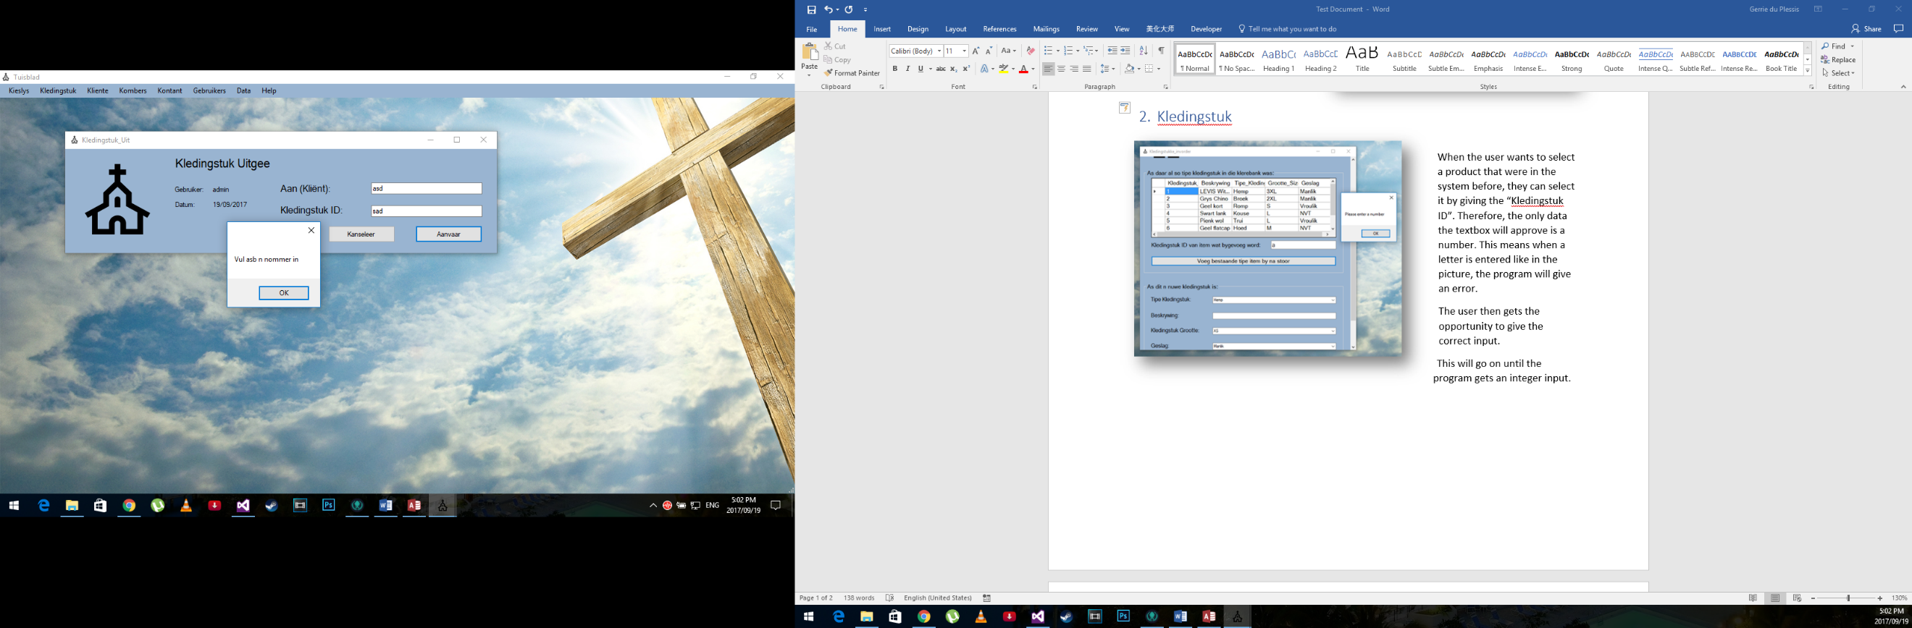

To give clothing to people we need to also remove it from the database. To do this, we need to know which clothing item were given and to whom it was given.

This both requires only the “Klient” to whom it will be given’s ID and the “Kledingstuk ID”. These both are integer values and therefore the programs validate to check whether the user gave and integer input.

In the case where the user gives a string as input, the program will give the message box error as shown in the figure above.

# Kliënt

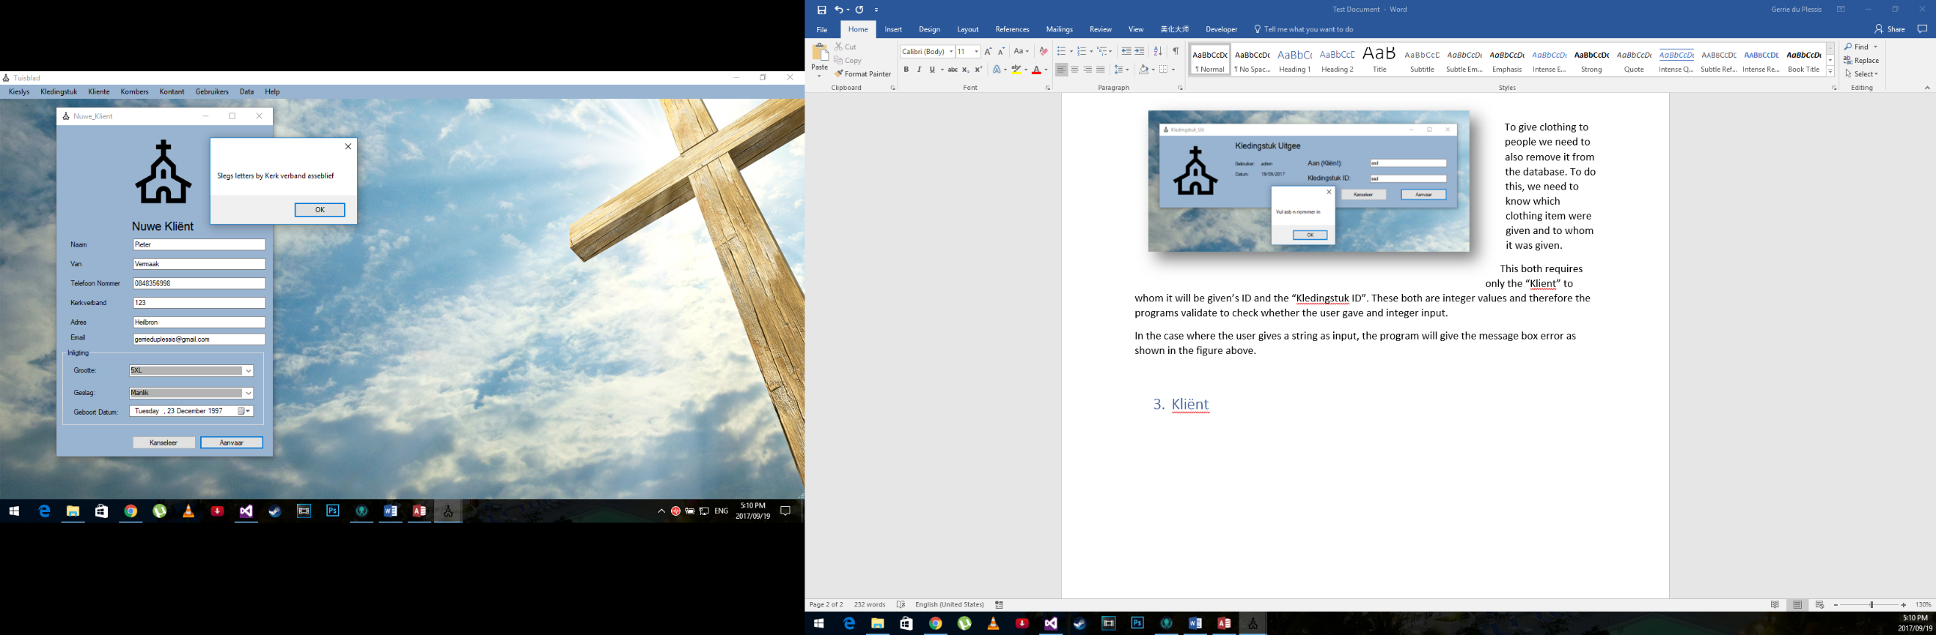

This form is to add a new client to the system.

This mostly consist of string inputs and one integer input. The program test each text box separately. In this case, we entered integer values in the “Kerkverband” textbox. Therefore, the program shows the error in the message box to show that the incorrect input was given and the solution to fix it.

This happens to all the fields where string inputs are required. The different text boxes show different errors.

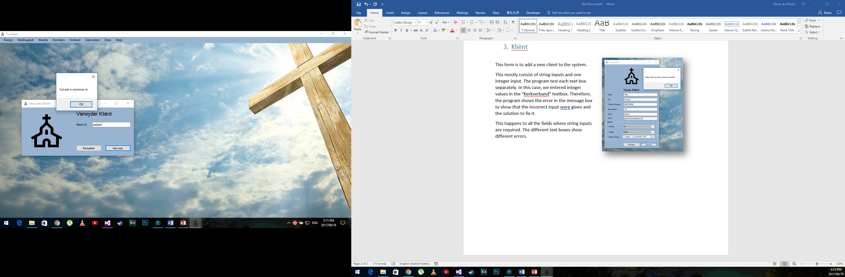

Here we want to remove a client from the system.

We only need the client ID to remove the client. The client ID is an integer input. If any other input is given than integer as shown in the figure to the left. The program will give the message box error to show how to correct your mistake.

# Kombers

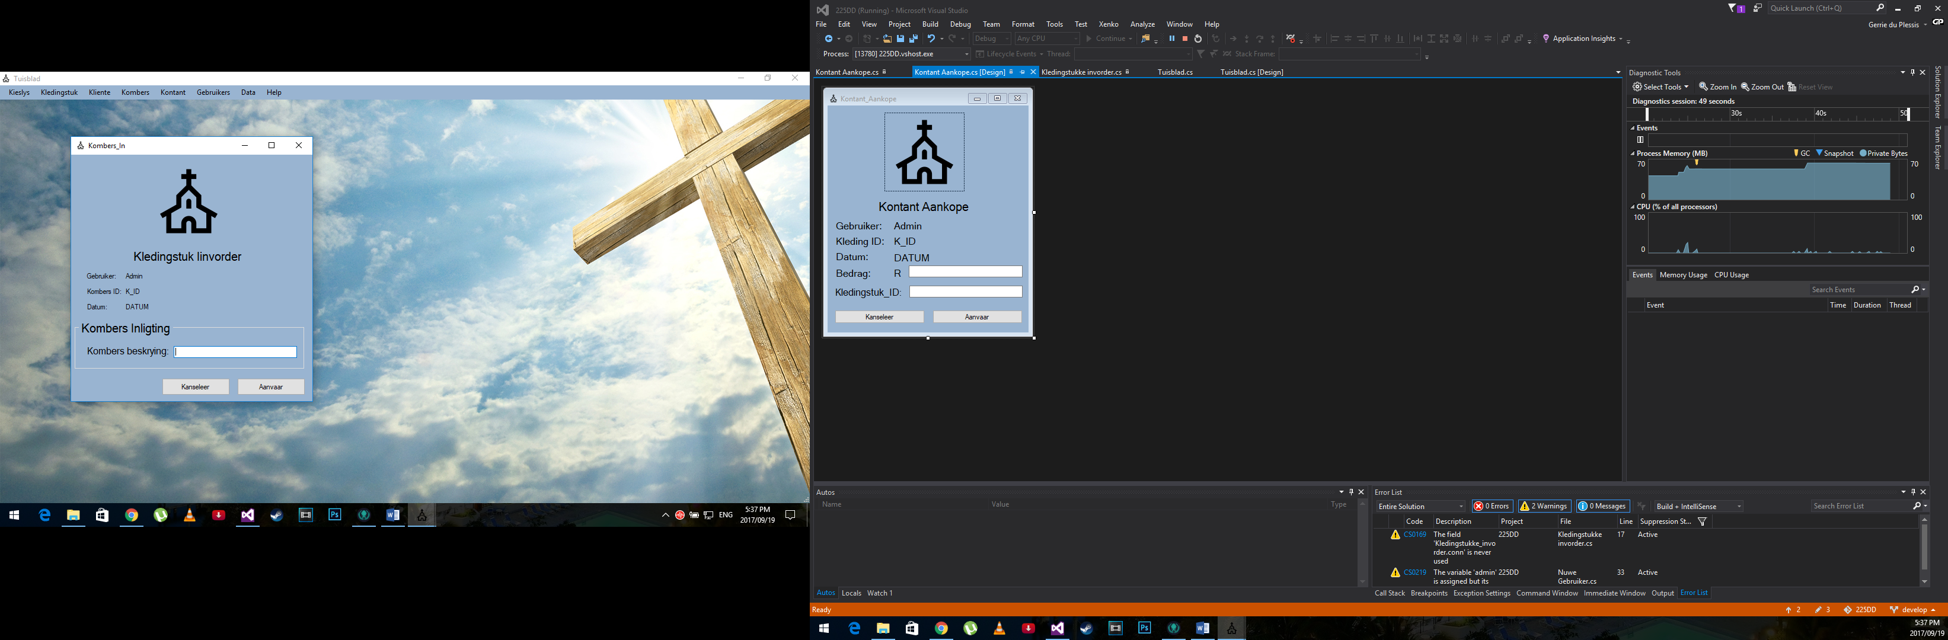

In the case where a new blanket comes in. The program automatically gives the blanket an ID. The user only need to give it a description. The description needs a sting input. The program will give an error in the case where any other input value was given

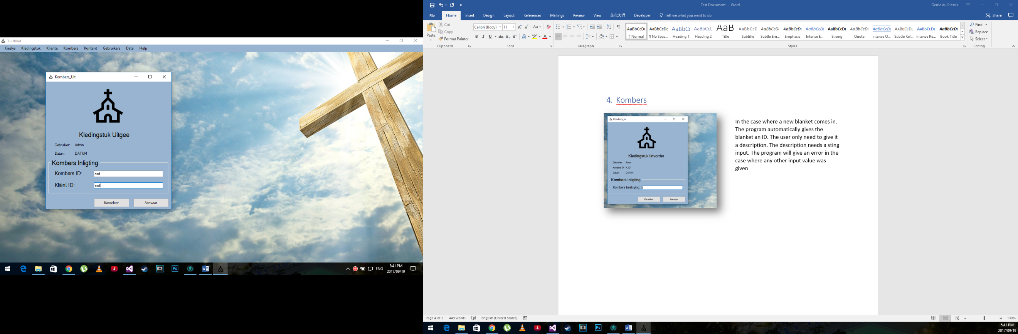

This is mostly the same as giving away clothes. The user must enter both the client ID as well as the blanket ID as integer values. In the case that it gets the wrong input the program will give the error message on how to correct the mistake.

# Kontant

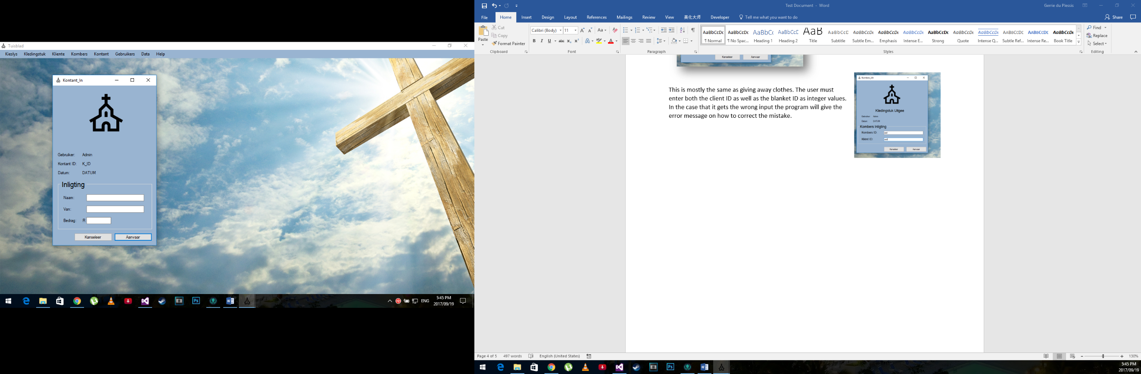This is where cash gets donated to the cause. They only data needed is the name and surname of the donator, they can be anonymous if they choose. Both the name and surname have string inputs. If any other input value is given the program will give the error message on how to fix the problem.

The amount field is the only integer input field. The same happens. If the wrong input value is given, the program will give the error message with how you can fix your problem.

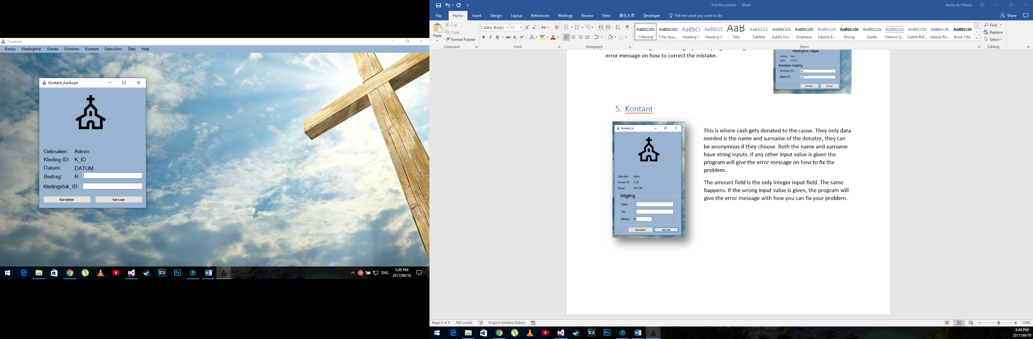

This form is to buy clothes. It has two integer input values needed.

If the wrong input value is given, the program will give the error message with how you can fix your problem.

# Gebruikers

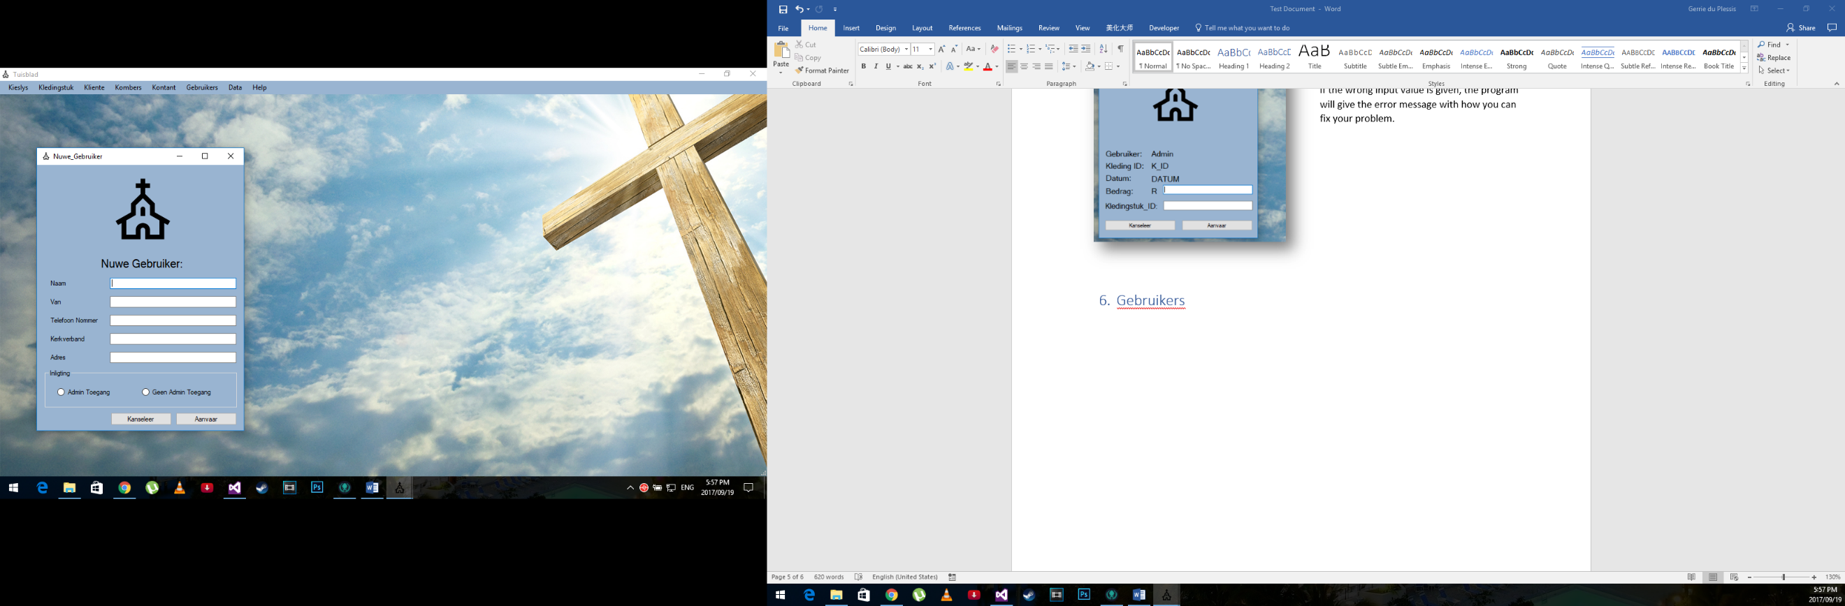

This form is to add a new user to the system.

This mostly consist of string inputs and one integer input. The program test each text box separately. In this case, we entered integer values in the “Kerkverband” textbox. Therefore, the program shows the error in the message box to show that the incorrect input was given and the solution to fix it.

This happens to all the fields where string inputs are required. The different text boxes show different errors.

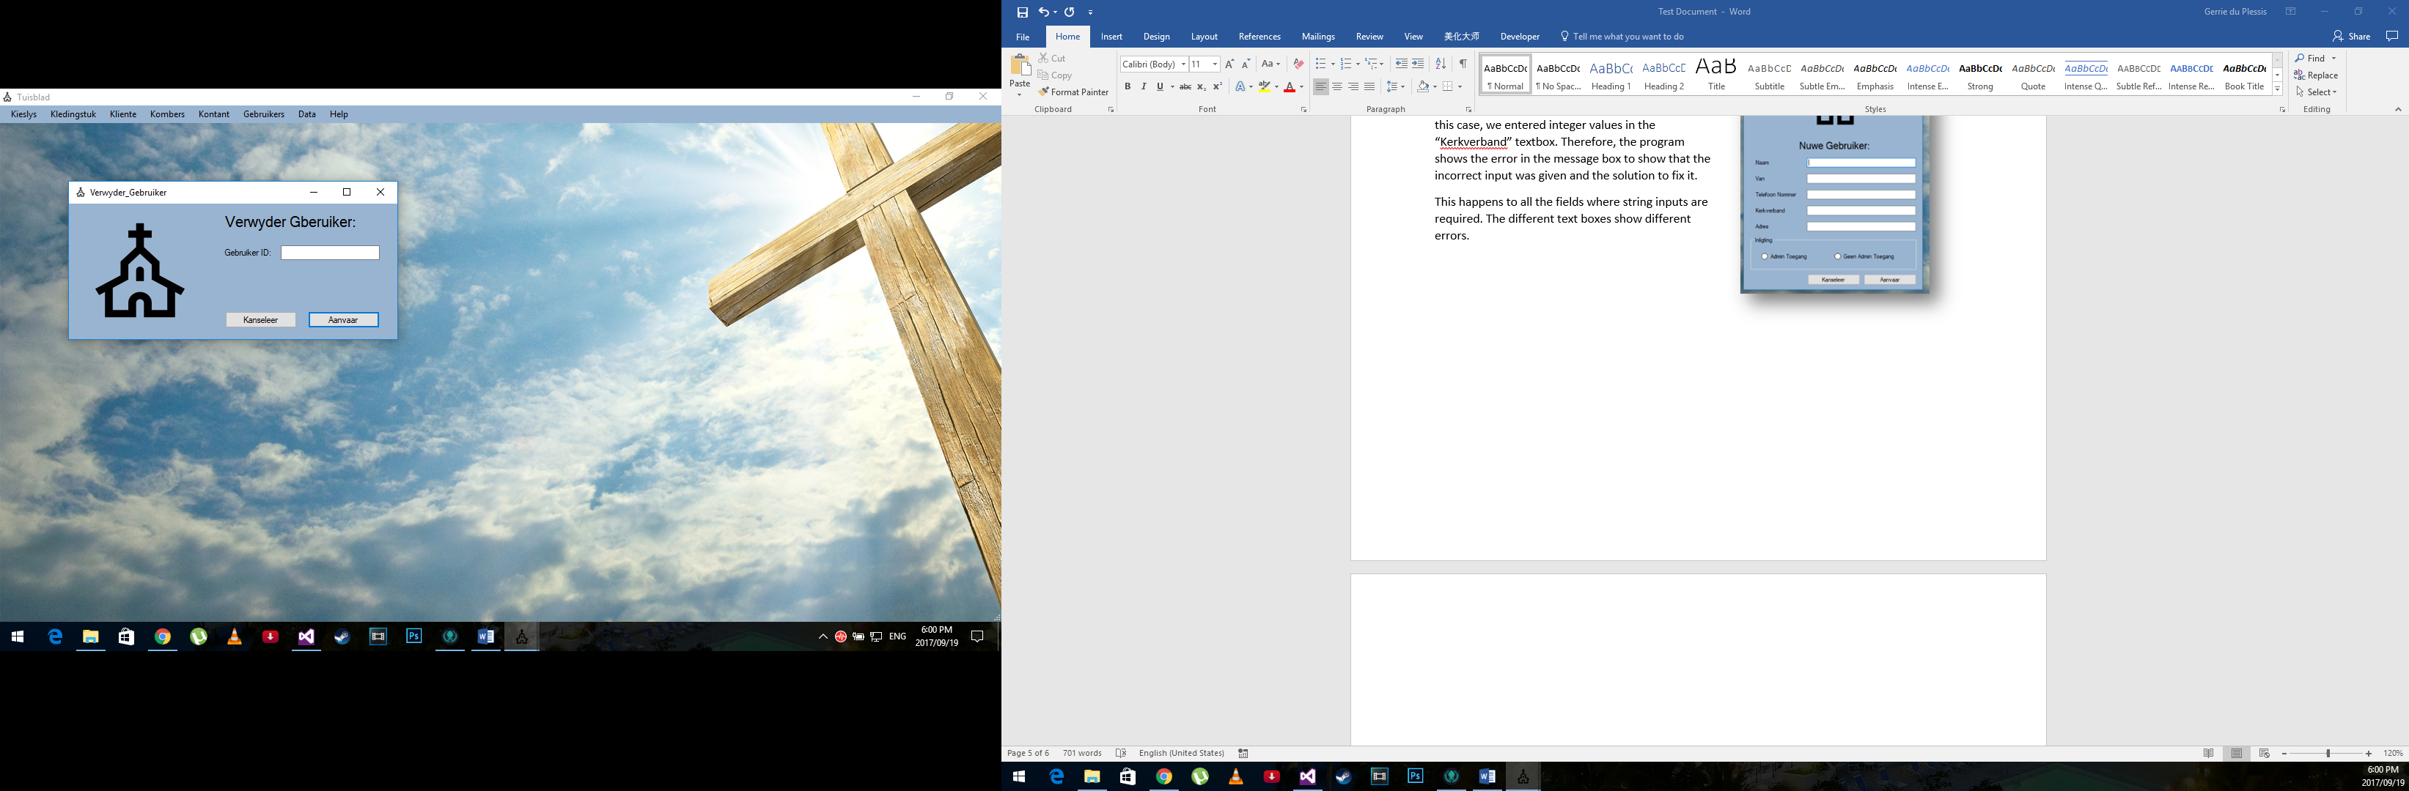

Here we want to remove a user from the system.

We only need the user ID to remove the client. The user ID is an integer input. If any other input is given than integer as shown in the figure to the left. The program will give the message box error to show how to correct your mistake

# Data